What is a file descriptor?
File descriptor is simply an index into the file descriptor table. For each process in our operating system, there is a process control block(PCB). PCB keeps track of the context of the process. So one of the fields within this is an array called file descriptor table.
Eg> 1: STDOUT, 0: STDIN, 2: STDERR
This array keeps track of all the resources that the process owns and can operate on. The file descriptor table holds pointers to the resources. Resources could be
- File
- Terminal I/O
- Pipes
- Socket for the communication channel between machines
- Any devices
How are file descriptors represented?
- File descriptors are typically represented as non-negative integers. The operating system assigns the lowest available file descriptor to a newly opened file. The file descriptor is used by the program to refer to the file when performing read, write, or other operations.
----------------------------------------------------------------------------------------------
- FD table = your program’s own list of open files
- • Global file table = real open file info (offset, read/write mode)
- • Inode table = file metadata and block locations (Think of a file system like a library –(a) Metadata = the information card about the book. (b). Block locations = where the actual pages are stored in the shelves. Without both, the OS cannot find or understand the file.)
- • Data blocks = actual file data on the disk
Macro | Value | Meaning
STDIN_FILENO | 0 | Standard input (keyboard)
STDOUT_FILENO | 1 | Standard output (screen/terminal)
STDERR_FILENO | 2 | Standard error (screen/terminal)
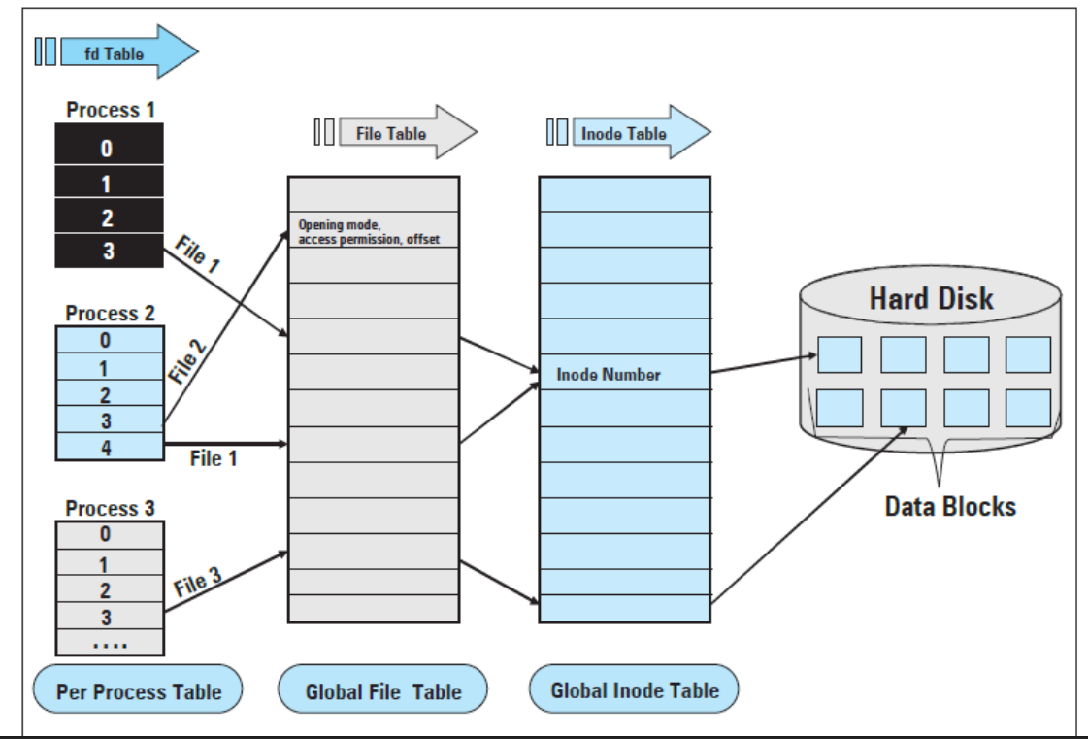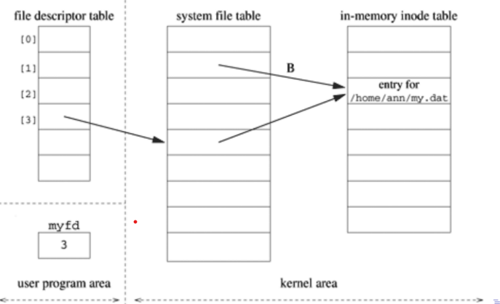
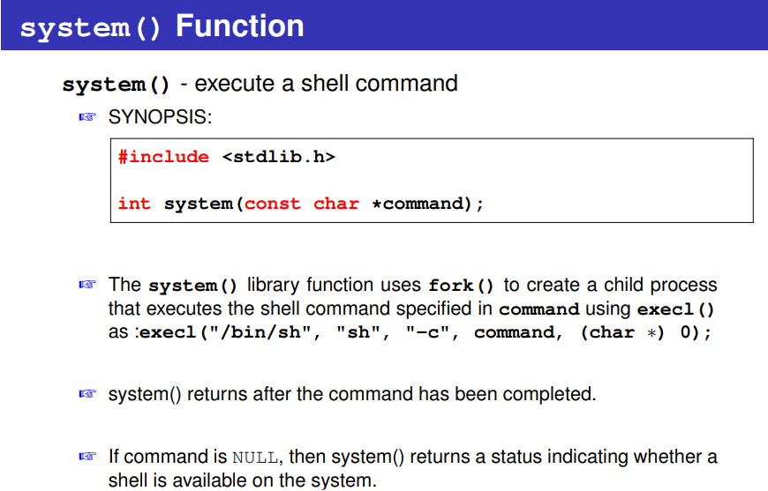
system() Function Return Value
The return value of system() is one of the following:
☞ If command is NULL, then a nonzero value if a shell is available, or 0 if
no shell is available.
☞ If a child process could not be created, or its status could not be retrieved, the return value is -1.
☞ If a shell could not be executed in the child process, then the return value
is as though the child shell terminated by calling _exit() with the status
127.
☞ If all system calls succeed, then the return value is the termination status
of the child shell used to execute command. (The termination status of
a shell is the termination status of the last command it executes.)
Example:
#include <stdio.h>
#include <stdlib.h>
int main() {
printf("Listing files in the current directory:\n");
// system() executes a command as if typed in the terminal
int status = system("ls -l");
if (status == -1) {
printf("Error executing system command!\n");
} else {
printf("\nsystem() executed successfully.\n");
}
return 0;
}
o/p:--
Listing files in the current directory:
total 20
-rwxr-xr-x 1 runner60 runner60 15984 Dec 5 18:52 a.out
-rw-r--r-- 1 runner60 runner60 394 Dec 5 18:52 main.c

system() executed successfully.
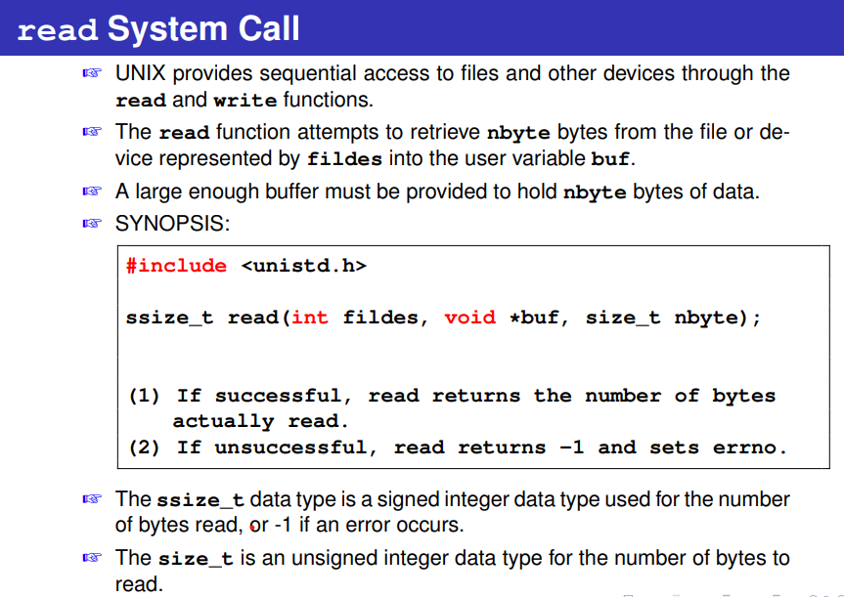
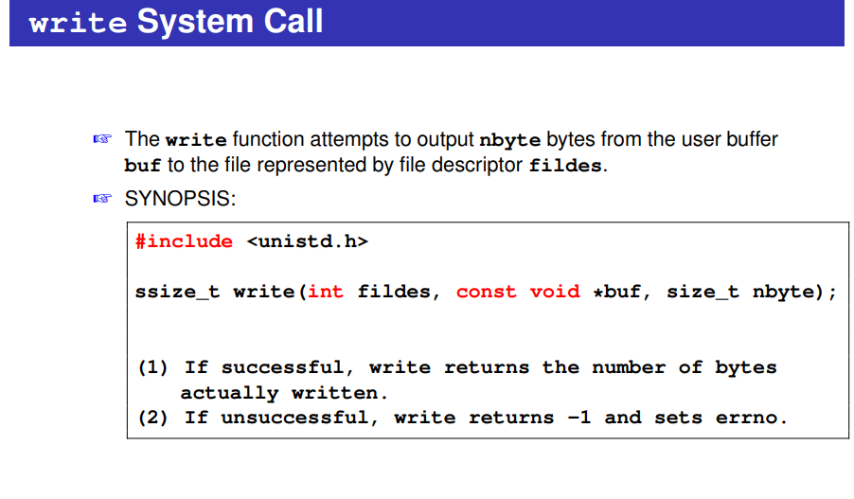✍ The open function creates an entry in the file descriptor table that points to an entry in the system file table.
✍ The open function returns the value 3, specifying that the file descriptor entry is in position three of the process file descriptor table.
✍ The system file table, which is shared by all the processes in the system, has an entry for each active open.
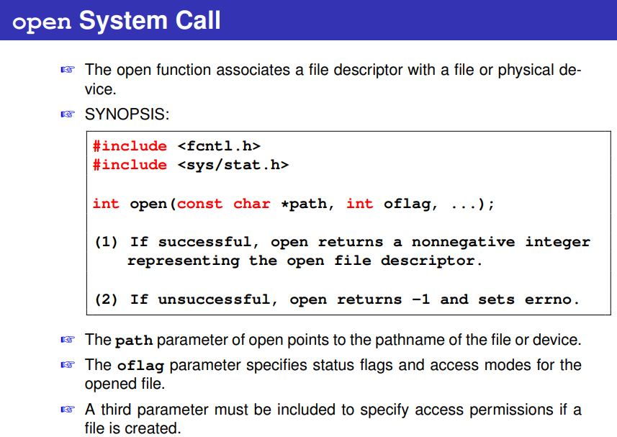
Flag | Meaning
O_RDONLY | Opened for read only
O_WRONLY | Opened for write only
O_RDWR | Opened for read & write
O_APPEND | Writes will always append to end of file
O_NONBLOCK | Non-blocking I/O
O_SYNC | Synchronous writes
O_DSYNC | Synchronized data writes
O_RSYNC | Synchronized read/writes

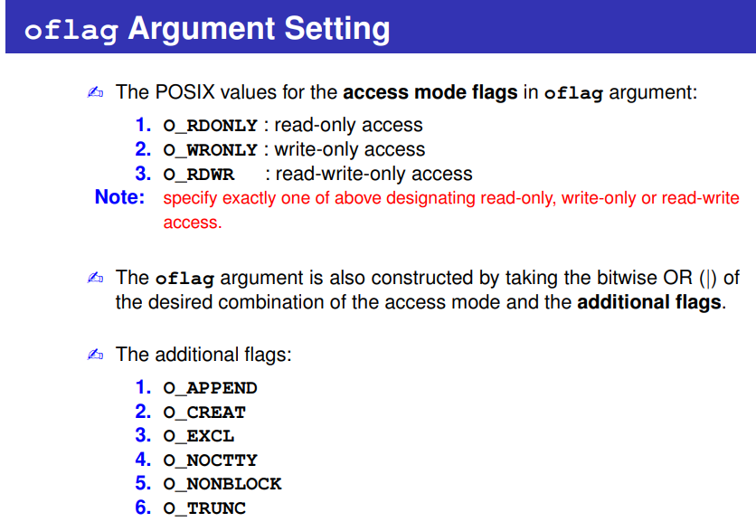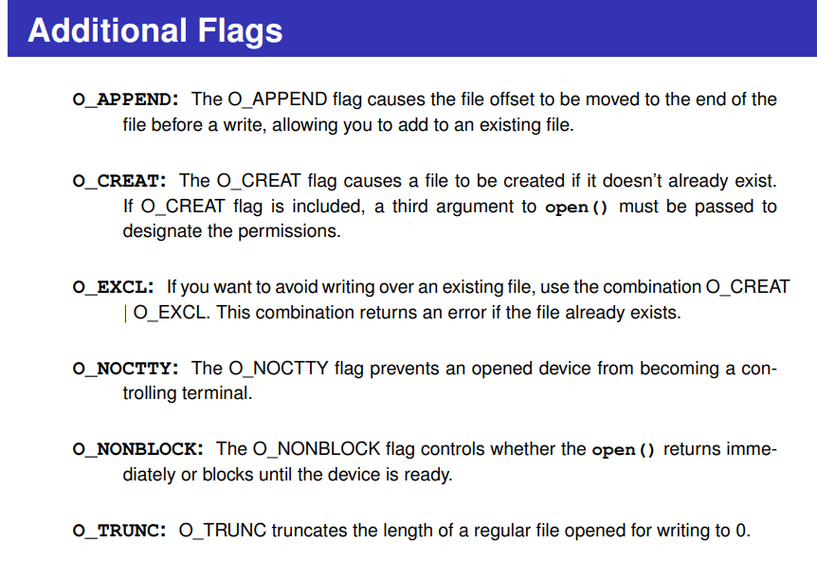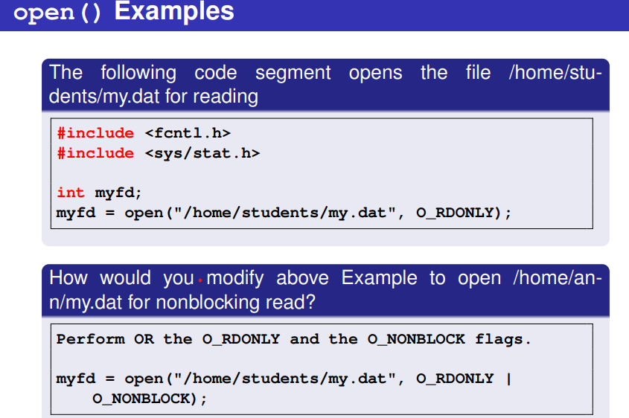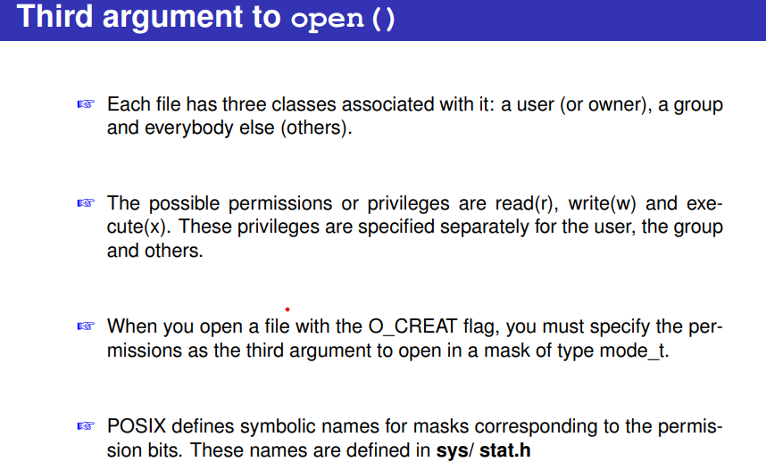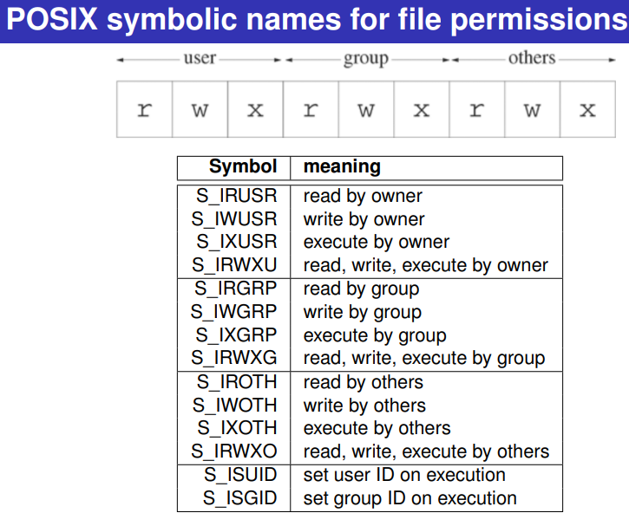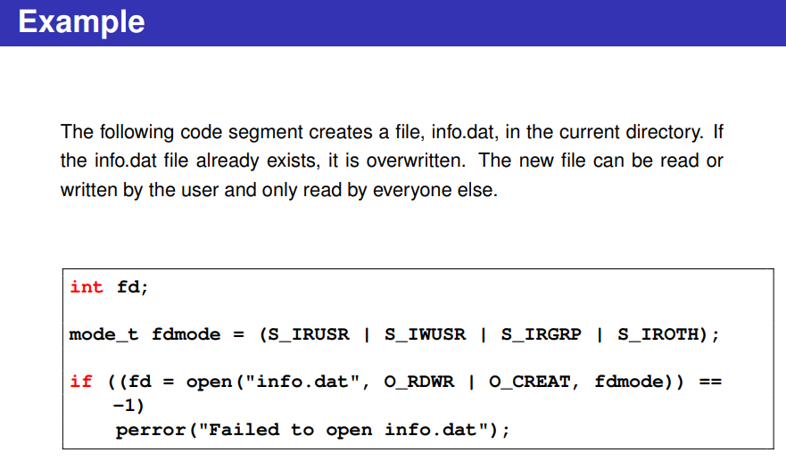
Example:
- fd=open("duptest.txt",O_WRONLY|O_CREAT|O_TRUNC, S_IRUSR|S_IWUSR|S_IRGRP);
- fd = open("file0644.txt", O_WRONLY | O_CREAT | O_TRUNC, 0644);
Remember:
Must use octal like 0644 or mode
…..2 way…………..
Octal Digit | Binary | Symbolic | Meaning
0 | 000 | --- | No permissions
1 | 001 | --x | Execute only
2 | 010 | -w- | Write only
3 | 011 | -wx | Write + execute
4 | 100 | r-- | Read only
5 | 101 | r-x | Read + execute
6 | 110 | rw- | Read + write
7 | 111 | rwx | Read + write + execute
Octal: 0 6 4 4
Who: --- Owner Group Others
Binary: 000 110 100 100
Symbol: --- rw- r-- r--
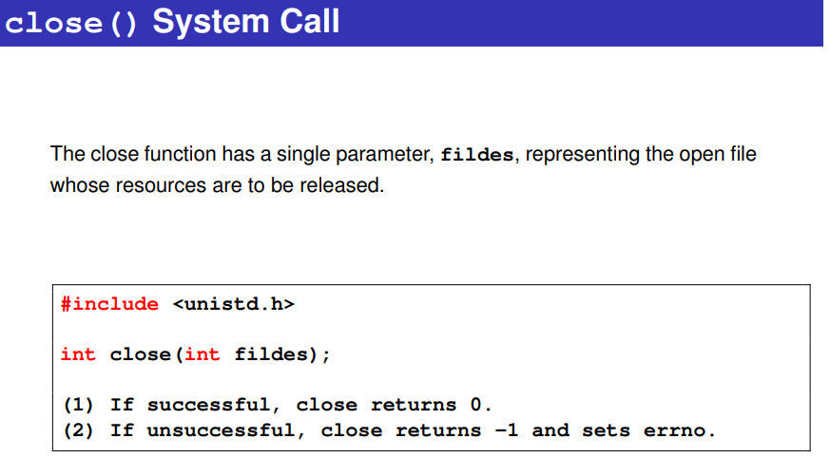
- Open- opens a file/ device (reading always started from 1st character in the file)
- Read- reads from an open file/ device
- Write-write to a file/ device (writing happened from the beginning or the content got appended to the original content)
- Close- close a file/ device
- Lseek- lseek() is used to move the file offset (cursor) within an open file. If we need to write from the middle then lseek() is used to move the pointer to the required location (fd, position , where are you specifying the position from – beginning, end )
syntax
off_t lseek(int fd, off_t offset, int whence);
- fd → file descriptor
- offset → how many bytes to move
- whence → reference position

- SEEK_SET: The file offset is set to offset bytes.
- SEEK_CUR: The file offset is set to its current location plus offset bytes.
- SEEK_END: The file offset is set to the size of the file plus offset bytes.

//1. Program to understand functions

#include<stdio.h>
#include<unistd.h>
#include<fcntl.h>
#include<sys/types.h>
#include<sys/stat.h>
int main()
{
int n,f,f1;
char buff[20];
f =open("check.txt", O_RDWR);//1234567890abcdefghijx1x2x3x4x5
read(f, buff, 10);
write(f, buff, 10);
read(f, buff, 10);
write(f, buff, 10);
close(f);
}
Given file content initially:
1234567890abcdefghijx1x2x3x4x5
After executing your program, the file becomes:
12345678901234567890 x1x2x3x4x5 x1x2x3x4x5

//2. Program to lseek

#include<stdio.h>
#include<unistd.h>
#include<fcntl.h>
#include<sys/types.h>
#include<sys/stat.h>
int main()
{
int n,f,f1;
char buff[20];
f =open("check.txt", O_RDWR);//1234567890abcdefghijx1x2x3x4x5
read(f, buff, 10);
write(1, buff, 10); // terminal --1234567890
lseek(f, 10, SEEK_CUR); // jump by 10 (at 20th)
read(f, buff, 10);
write(1, buff, 10); //terminal --- x1x2x3x4x5
close(f);
}
//3. Program to lseek ex2
#include<stdio.h>
#include<unistd.h>
#include<fcntl.h>
#include<sys/types.h>
#include<sys/stat.h>
int main()
{
int n,f,f1;
char buff[20];
f =open("check.txt", O_RDWR);//1234567890abcdefghijx1x2x3x4x5
f1=lseek(f, 10, SEEK_SET);
printf(“pointer is at %d position\n”, f1); // 10th position
read(f, buff, 10); // read from 10th index
write(1, buff, 10);// print in terminal
close(f);
}

//4. Program to lseek ex3

#include<stdio.h>
#include<unistd.h>
#include<fcntl.h>
#include<sys/types.h>
#include<sys/stat.h>
int main()
{
int n,f,f1;
char buff[20];
f =open("check.txt", O_RDWR);//1234567890abcdefghijx1x2x3x4x5
f1=lseek(f, -11, SEEK_END); (30-11 =19 index)
read(f, buff, 10);// jx1x2x3x4x5
write(1, buff, 10);// on terminal
close(f);
}
File pointer is a pointer returned by fopen() library function. It is used to identify a file. It is passed to a fread() and fwrite() function.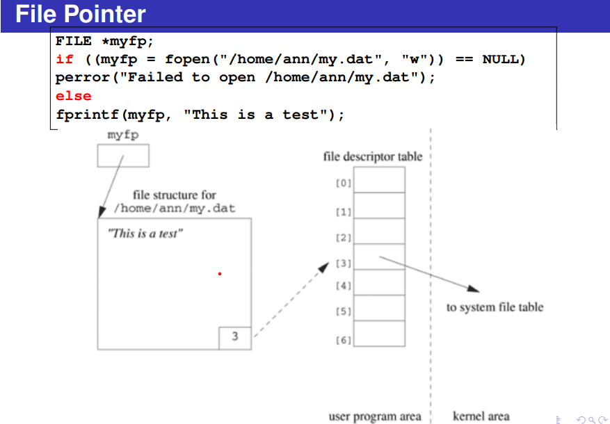
A file pointer is a special pointer of type FILE* used in C to access and control files.
It does not point to memory, but to a structure maintained by the OS that stores file information:
✔ Current position in the file
✔ File name and status
✔ Buffer location
✔ Mode in which file is opened
Internally, it represents a handle used by C to perform file I/O.
FILE *fp;
- FILE → A structure defined in <stdio.h>
- *fp → Pointer variable that stores the address of a FILE structure

fopen() – Opens a file
FILE *fopen(const char *filename, const char *mode);

Arguments:
- filename → name/path of file
- mode → "r", "w", "a", "r+", "w+", "a+" etc.

Returns:
- FILE* → if successful
- NULL → if file cannot be opened

fclose() – Closes a file
int fclose(FILE *fp);

Arguments:
- fp → file pointer returned by fopen

Returns:
- 0 → success
- EOF → failure

3. fgetc() – Reads a character
int fgetc(FILE *fp);

Returns:
- Character read (as int)
- EOF if end-of-file or error

fputc() – Writes a character
int fputc(int ch, FILE *fp);

5. fgets() – Reads a string
char *fgets(char *str, int n, FILE *fp);

Reads up to n-1 characters.

6. fputs() – Writes a string
int fputs(const char *str, FILE *fp);

7. fprintf() / fscanf() – File formatted I/O

fprintf()
int fprintf(FILE *fp, const char *format, ...);

fscanf()
int fscanf(FILE *fp, const char *format, ...);

8. ftell() – Returns current file position
long ftell(FILE *fp);

9. fseek() – Moves file pointer to a position
int fseek(FILE *fp, long offset, int origin);

origin options:
- SEEK_SET → beginning of file
- SEEK_CUR → current position
- SEEK_END → end of file

🔟 rewind() – Moves file pointer to beginning
void rewind(FILE *fp);

Example:
#include <stdio.h>
int main() {
FILE *fp;
char text[50];

fp = fopen("data.txt", "w"); // open for writing
fputs("Hello File Pointer!", fp);
fclose(fp);
fp = fopen("data.txt", "r"); // open for reading
fgets(text, 50, fp);
printf("File contains: %s\n", text);
fclose(fp);
return 0;
}
o/p: in file
Hello File Pointer! 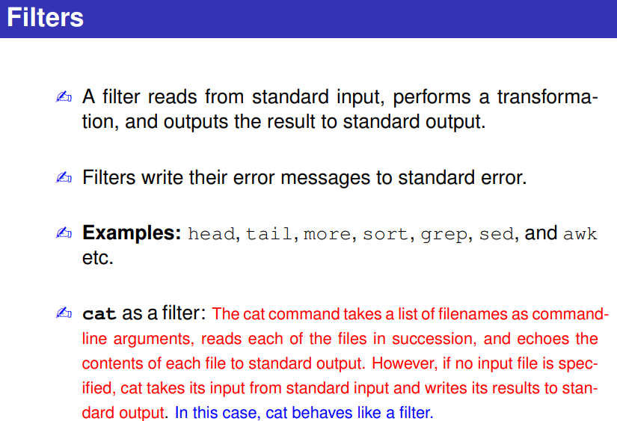 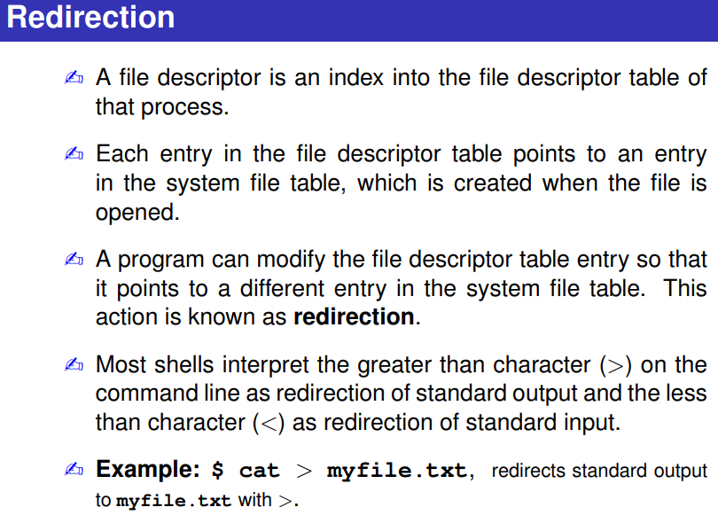
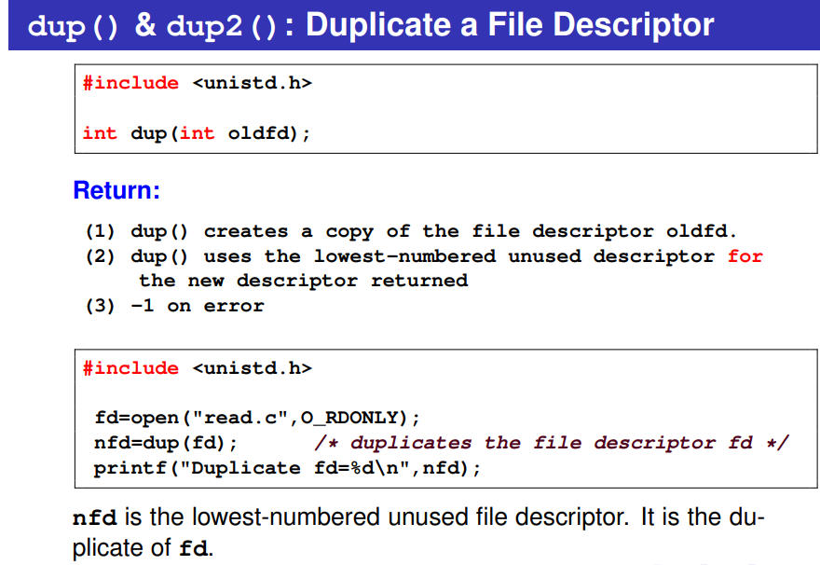
Example:
#include <stdio.h>
#include <unistd.h>
#include <fcntl.h>
#include <sys/types.h>
#include <sys/stat.h>
int main()
{
int fd;
fd=open("duptest.txt",O_WRONLY|O_CREAT|O_TRUNC, S_IRUSR|S_IWUSR|S_IRGRP);
printf("File descriptor: fd=%d\n",fd);//3
dup(STDOUT_FILENO);/* save descriptor STDOUT_FILENO */
close(1); /* closing 1, creates an empty slot */
dup(fd); /* duplicate fd =1 to standard output */
close(fd);
write(STDOUT_FILENO,"USP\n",4);
write(STDOUT_FILENO,"DOS\n",4);
return 0;
}
Content in file
USP
DOS
DUP1
#include<stdio.h>
#include<unistd.h>
#include<fcntl.h>
#include<sys/types.h>
#include<sys/stat.h>
int main()
{
int fd, fd1;
fd =open("check.txt", O_RDWR);
printf("old file descriptor %d\n", fd);
fd1=dup(fd);
printf("New file descriptor %d\n", fd1);
}
o/p: old file descriptor 3
New file descriptor 4
Remember:
• You cannot choose the new FD number — the system assigns it automatically.
• Creates a duplicate of oldfd.
• Returns the lowest-numbered available file descriptor.
• The new FD shares the same file table entry as oldfd (file offset, flags).
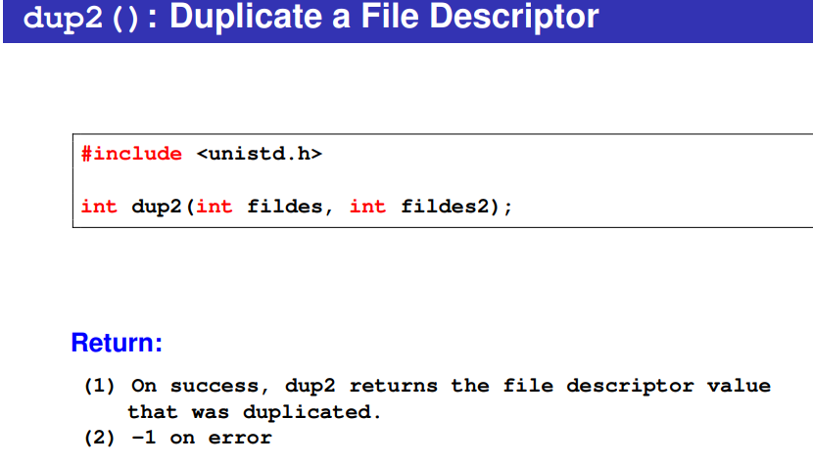 Example:
#include <stdio.h>
#include <unistd.h>
#include <fcntl.h>
#include <sys/types.h>
#include <sys/stat.h>
#define CREATE_FLAGS (O_WRONLY | O_CREAT | O_APPEND) //O_WRONLY → write only, O_CREAT → create if not exists, O_APPEND → write will always append at end
#define CREATE_MODE (S_IRUSR | S_IWUSR | S_IRGRP | S_IROTH)
int main(void) {
int fd;
fd = open("dup2test.txt", CREATE_FLAGS, CREATE_MODE);// File is created (if it didn’t exist) or opened in append mode.
if (dup2(fd, STDOUT_FILENO) == -1) {// Standard output (fd 1) now points to the same file i.e. STDOUT_FILENO=1
perror("Failed to redirect standard output");
return 1;
}
close(fd); // fd (3) is closed but STDOUT_FILENO (1) still works → writing to file
write(STDOUT_FILENO, "OK", 2); // "OK" is written into dup2test.txt
return 0;
}
dup() vs dup2()
dup2(fd1,fd2); Is equivalent to
close(fd2);
dup(fd1);
DUP2
#include<stdio.h>
#include<unistd.h>
#include<fcntl.h>
#include<sys/types.h>
#include<sys/stat.h>
int main()
{
int fd, fd1;
fd =open("check.txt", O_RDWR);
printf("old file descriptor %d\n", fd);//3
fd1=dup2(fd,7);
printf("New file descriptor %d\n", fd1);//7
}
Remember
Steps- 1. Close newfd (if open)
2. copies oldfd to newfd
• Duplicates oldfd into the exact FD number you specify (newfd).
• If newfd was already open, it is closed first.
• Returns newfd on success.
• Shares the same file table entry (file offset, flags) like dup().
• You can control the file descriptor number.
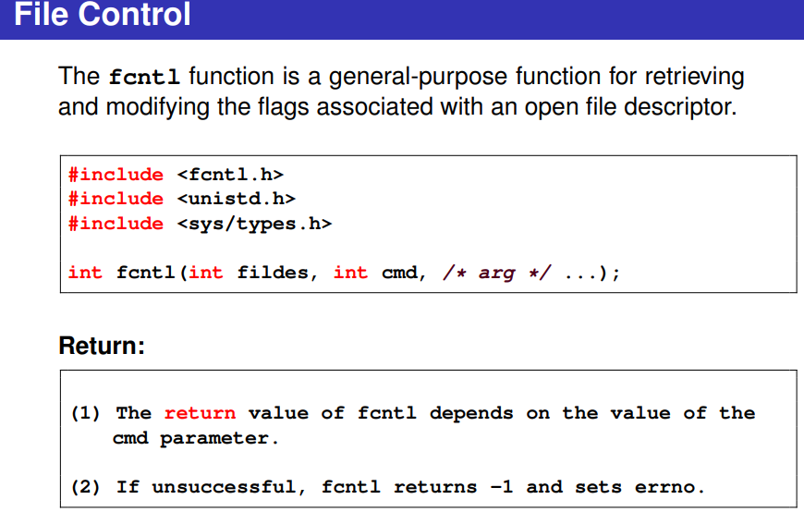
🔹 What is fcntl()?
fcntl() is a file control system call used to:
- Get or set file descriptor flags
- Get or set file status flags
- Duplicate file descriptors
- Apply locking on files (advisory locking)
Command | Purpose
F_GETFL | Get file status flags
F_SETFL | Set file status flags
F_DUPFD | Duplicate a file descriptor
F_GETFD | Get file descriptor flags
F_SETFD | Set file descriptor flags (like close-on-exec)
F_SETLK / F_SETLKW | Lock a file region (advisory locking)
Case 1
Get or set file status flags
#include <stdio.h>
#include <fcntl.h>
#include <unistd.h>
int main() {
int fd;
int flags;
// Open a file
fd = open("example.txt", O_WRONLY | O_CREAT, 0644);
if (fd < 0) {
perror("open failed");
return 1;
}
// Get current file status flags
flags = fcntl(fd, F_GETFL); /* F_GETFL → get the file status flags of the file descriptor fd. Flags include: O_RDONLY, O_WRONLY, O_RDWR, O_APPEND, O_NONBLOCK, etc.*/
if (flags < 0) {
perror("fcntl F_GETFL failed");
return 1;
}
printf("Original flags: %d\n", flags); /*flag value is printed. Prints the current flags as a number (not very human-friendly, just for info).*/
// Set the file to append mode
fcntl(fd, F_SETFL, flags | O_APPEND); /*F_SETFL lets you change the file’s settings. flags | O_APPEND → keeps the old flags (write-only) and adds append mode. Append mode means every write goes at the end of the file, no matter where the file pointer currently is.*/
// Write some data
write(fd, "Hello\n", 6); //save to file
write(fd, "World\n", 6); //save to file
close(fd);
return 0;
}
0644
The number is in octal (base 8):
0 6 4 4
Digit | Who | Permission
6 | Owner | Read + Write → 4 + 2 = 6
4 | Group | Read only → 4
4 | Others | Read only → 4
So 0644 means:
- Owner → read + write ✅
- Group → read only ✅
- Others → read only ✅
Explanation
- F_GETFL → Gets current file status flags (like O_WRONLY, O_APPEND)
- F_SETFL → Sets new flags. Here we add O_APPEND
- All writes now append at the end of the file
- This does not affect the file descriptor number, only the flags.
- On console:
Original flags: 1
(1 corresponds to O_WRONLY)
example.txt
Hello
World
Case 2
Get or Set File Descriptor Flags
File descriptor flags control properties of the file descriptor itself, like close-on-exec.
- F_GETFD → get file descriptor flags
- F_SETFD → set file descriptor flags
Example: Close-on-exec flag
#include <stdio.h>
#include <fcntl.h>
#include <unistd.h>

int main() {
int fd = open("example.txt", O_WRONLY | O_CREAT, 0644);

// Get current FD flags
int fd_flags = fcntl(fd, F_GETFD);
printf("Original FD flags: %d\n", fd_flags);

// Set FD_CLOEXEC flag (close on exec)
fcntl(fd, F_SETFD, fd_flags | FD_CLOEXEC);

// Verify
fd_flags = fcntl(fd, F_GETFD);
printf("New FD flags: %d\n", fd_flags);

close(fd);
return 0;
}
- FD_CLOEXEC → file descriptor automatically closes if exec() is called.
Case 3
Duplicate File Descriptors
- F_DUPFD → duplicate a file descriptor to the lowest available FD ≥ a given number
- Similar to dup() / dup2()
Example: Duplicate fd
#include <stdio.h>
#include <fcntl.h>
#include <unistd.h>

int main() {
int fd = open("example.txt", O_WRONLY | O_CREAT, 0644);

// Duplicate fd to a new fd ≥ 5
int newfd = fcntl(fd, F_DUPFD, 5);
printf("Original FD: %d, Duplicated FD: %d\n", fd, newfd);

write(newfd, "Hello via newfd\n", 16);

close(fd);
close(newfd);
return 0;
}
- Now both fd and newfd point to the same file entry (same file offset, same file flags).
Case 4.
Apply File Locking (Advisory Locking)
- F_SETLK → set a lock (non-blocking)
- F_SETLKW → set a lock (blocking, waits if already locked)
- F_GETLK → query if lock is possible
Example: Lock a file region
#include <stdio.h>
#include <fcntl.h>
#include <unistd.h>
#include <string.h>

int main() {
int fd = open("example.txt", O_WRONLY | O_CREAT, 0644);

struct flock lock;
memset(&lock, 0, sizeof(lock));
lock.l_type = F_WRLCK; // write lock
lock.l_whence = SEEK_SET;
lock.l_start = 0; // start of file
lock.l_len = 0; // lock entire file

// Try to acquire lock
if(fcntl(fd, F_SETLK, &lock) == -1) {
perror("Cannot lock file");
} else {
printf("File locked!\n");
}

// Do some writing
write(fd, "Locked write\n", 13);

// Release lock
lock.l_type = F_UNLCK;
fcntl(fd, F_SETLK, &lock);

close(fd);
return 0;
}
- Advisory locks prevent other processes from writing if they respect locks.
- Not enforced by kernel unless all programs use the same locking convention.

